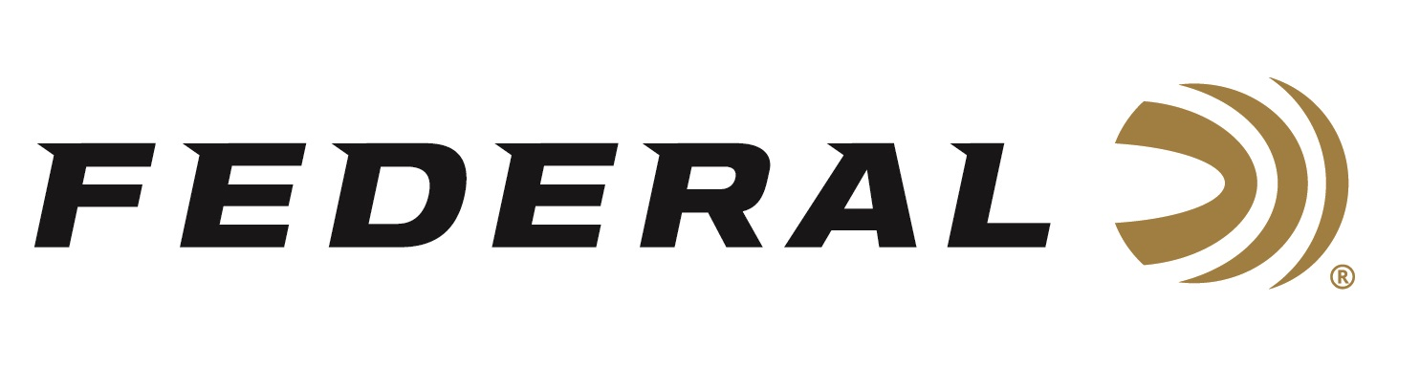

FOR IMMEDIATE RELEASE

Vista Outdoor Ammunition Brands Awarded Major International Police Contract

ANOKA, Minnesota – April 20, 2020 – Through our Australian distribution partner, NIOA, Vista Outdoor ammunition brands; Federal, Speer, and Force on Force will supply police agencies in Australia with the world’s best duty and training ammunition. The contract was awarded by the Victoria Police in Australia and allows for other Australian Affiliated Policing Entities to procure ammunition under the same terms and conditions.

“We are extremely pleased with this prestigious contract award,” said Jason Vanderbrink, President of Federal Ammunition. According to Vanderbrink, “this award continues to validate the global trust our Federal, Speer, and Force on Force products have when it comes to protecting the international law enforcement community.”

“The selection criteria included a mix of technical capability and price,” said David Leis, VP of Law Enforcement, Government and International Sales. One of the differentiators is Federal’s exclusive Catalyst primer. It’s a lead-free technology providing the most reliable, consistent ignition possible. Leis said, “with this contract award, Vista Outdoor ammunition brands and NIOA continue demonstrating surety of supply, professional capability, and the ability to meet all specifications while delivering value.”

Federal ammunition can be found at dealers nationwide or purchased online direct from Federal. For more information on all products from Federal or to shop online, visit www.federalpremium.com.

Press Release Contact: JJ Reich
Senior Manager – Press Relations
E-mail: VistaPressroom@VistaOutdoor.com

About Federal Ammunition
Federal, headquartered in Anoka, MN, is a brand of Vista Outdoor Inc., an outdoor sports and recreation company. From humble beginnings nestled among the lakes and woods of Minnesota, Federal Ammunition has evolved into one of the world's largest producers of sporting ammunition. Beginning in 1922, founding president, Charles L. Horn, paved the way for our success. Today, Federal carries on Horn's vision for quality products and service with the next generation of outdoorsmen and women. We maintain our position as experts in the science of ammunition production. Every day we manufacture products to enhance our customers' shooting experience while partnering with the conservation organizations that protect and support our outdoor heritage. We offer thousands of options in our Federal Premium and Federal® lines-it's what makes us the most complete ammunition company in the business and provides our customers with a choice no matter their pursuit.

